NAME: **STANLEY NGUGI CHEGE**

REG. NO: **SCT212-0065/2017**

UNIT: **BCT 2401 Operations Research**

-----------------------------------------------------------------------------------------------------------------------------------------------

1. **Explain the following terms as used in linear programming, Feasible solution, degenerate solution and Sequencing.**

**Feasible solution -** A solution that satisfies all the constraints of a linear programming problem

**Degenerate solution -** A degenerate solution occurs when a basic feasible solution contains a smaller number of non-zero variables than the number of independent constraints when values of some basic variables are zero

**Sequencing -** This is the selection of an appropriate order in which a number of jobs can be assigned to a finite number of service facilities so as to optimize the outputs in terms of time, cost or profit.

1. **Define the term Linear Programming and outline the four steps followed when formulating a linear programming model mathematically.**

**Linear programming** is an optimization technique used to maximize or minimize an objective function given a number of constraints, which are given as inequalities

**STEPS**

1. Study the problem and identify the decision variables
2. Construct the objective function
3. Construct the constraints.
4. Add the non-negative part.
5. **Distinguish between the following terms as used in Network analysis**
   * 1. **Directed arc and undirected arc -** A directed arc is one in which the edges have direction, usually indicated with an arrow on the edge, while an undirected arc is an edge that has no arrow, that is, both ends of an undirected arc are equivalent with no head or tail.
     2. **Optimistic time and pessimistic time -** Optimistic time is the least amount of time it can take to complete a task while pessimistic time is the maximum amount of time it should take to complete a task
6. **A furniture manufacturing firm plans to make two products chairs and tables from its available resources, which consist 400 board feet of mahogany timber and 450 man-hours of labour. It knows that to make a chair requires 5 board feet and 10 man-hours which yield a profit of ksh 45, while each table uses 20 board feet and 15 man-hours which also yield a profit of sh80.** 
   * 1. **Formulate a linear programming model for above given information**

**Let**

X1 = Chair

X2 = Table

**Profit** = 45X1 + 80X2

**Max(Z)**

45X1 + 80X2

5X1 + 20X2 <= 400

10X1 + 15X2 <= 450

X1, X2 >= 0

* + 1. **Use the formulated linear Programming model above to determine how many chairs and tables the firm can make keeping within its resource constraints so as to maximize the profit**

1. **A company manufactures two products A and B. Each unit of B takes twice as long to produce as one unit of A and if the company were to produce only A it would have time to produce 2000 units per day. The availability of raw material is sufficient to produce 1500 units per day of both A and B combined. Product B requires special ingredient and only 600 units can be made per day. If A fetches Ksh2 as profit per unit and B fetches a profit of Ksh 4 per unit, find the optimum product mix. Use graphical method**

**Let**

Product A = X1

Product B = X2

**Profit** 2X1 + 4X2

**Constraints**

X1 + 2X2 <= 2000

X1 + X2 <= 1500

X2 <= 600

X1, X2 >= 0

Graph:

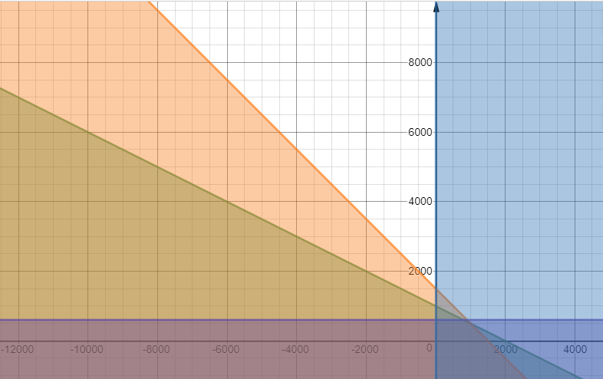

1. **A company makes two types of sofas, regular and long, at two locations, one in Msamvu and one in Kihonda. The plant in Msamvu has a daily operating budget of Tsh 45,000,000 and can produce at most 300 sofas daily in any combination. It costs Tsh 150,000 to make a regular sofa and Tsh 200,000 to make a long sofa at the Msamvu plant. The Kihonda plant has a daily operating budget of Ksh 36,000,000, can produce at most 250 sofas daily in any combination and makes a regular sofa for Ksh 135,000 and a long sofa for Ksh 180,000. The company wants to limit production to a maximum of 250 regular sofas and 350 long sofas each day. If the company makes a proﬁt of Ksh 50,000 on each regular sofa and Ksh 70,000 on each long sofa, how many of each type should be made at each plant in order to maximize proﬁt? Formulate this problem as an LP mode**

Let

x1 = regular sofas made in Msamvu

x2 = long sofas made in Msamvu

x3 = regular sofas made in Kihonda

x4 = long sofas made in Kihonda

max(z)

50000x1 + 70000x2 + 50000x3 + 70000x4

150000x1 + 200000x2 ≤ 45000000 (money constraint at Msamvu)

x1 + x2 ≤ 300 (Msamvu sofa limit)

135000x3 + 180000x4 ≤ 36000 (money constraint at Kihonda)

x3 + x4 ≤ 250 (Kihonda sofa limit)

x1 + x3 ≤ 250 (regular sofa limit)

x2 + x4 ≤ 350 (long sofa limit)

x1 ≥ 0; x2 ≥ 0; x3 ≥ 0; x4 ≥ 0

1. **The project has been broken down into 10 activities with the following predecessors and duration.**

|  |  |  |
| --- | --- | --- |
| Activity | Predecessor | Duration |
| A | - | 3 |
| B | - | 5 |
| C | B | 3 |
| D | A,C | 4 |
| E | D | 8 |
| E | F | 2 |
| G | F | 4 |
| H | F | 2 |
| I | B | 5 |
| J | H,E,G | 3 |

**Draw the network diagram and identify the critical path**

A,3

B,5

C,3

D,4

E,8

I,5

F,2

G,4

H,2

J,3

START

END

**CRITICAL PATH: (Dotted)**

B 🡪 C 🡪 D 🡪 E 🡪 F 🡪 G 🡪 J

1. **A company manufactures two products Q and W on three machines A, B and C. Q requires 1 hrs on machine A, 1 hr on machine B and C and yields a revenue of USD 3. Product W requires 2 hrs on machine A and 1 hr on machine B and C and yields revenue of USD 5. In the comming period the available time of three machines A, B and C are 2000 hrs, 1500 hrs and 600 hrs respectively. Find the optimal product mix.**

**Let**

Product Q = X1

Product W = X2

**Max (Z)** = 3x1 + 5x2

X1 + 2X2 <= 2000 (Machine A)

X1 + X2 <= 1500 (Machine B)

X2 <= 600 (Machine C)

X1, X2 >= 0